
Foundation Maths GCSE: Breakfast Warm Up: Target 4 Calculator
Express 0.23 as a percentage. | Find the median:  $$9, 9, 3, 12, 8$$ | Convert 7kg into grams. | Write $23.759$ to 1 decimal place. | Simplify:  $$6a+2b+a+3b$$
Find the range:  $$5, 4, 7, 16, 13, 8, 14$$ | Find the output: | Find the input: | Expand:  $$2(5x+1)$$ | Find the size of angle $x.$ 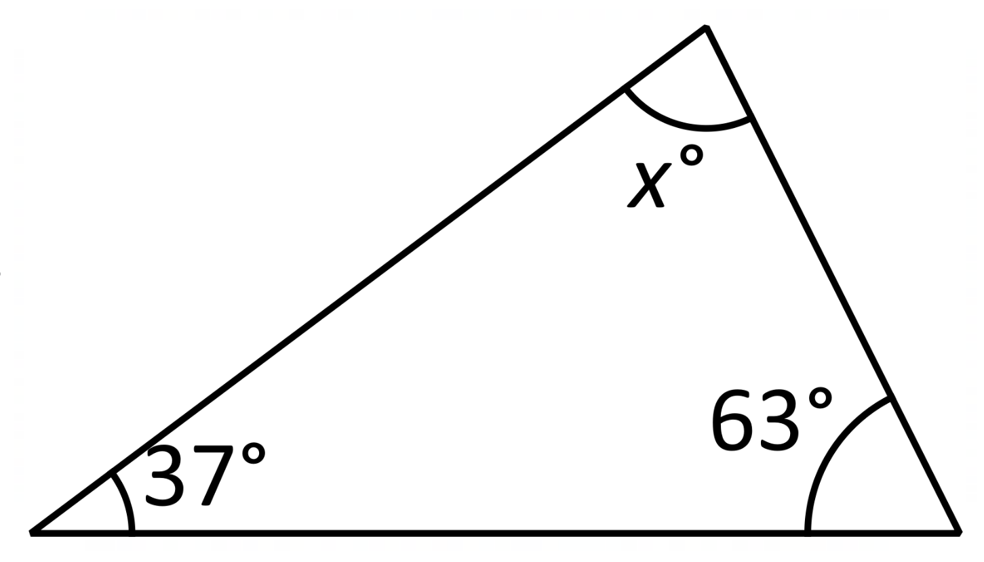
Write down the first 5 multiples of 23. | Jim buys 2 coffees for £2.45 each and 3 cakes for £1.79 each. How much change will he get from £20? | 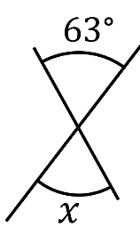  Find angle $x.$ | Find the missing number:  _____ $×5=-55$ | Simplify:  $$x^{6}×x^{7}$$
Katie buys some bottles of water for £24. She sells them for £30.  Calculate her percentage profit. | Factorise:  $$10y-15$$ | Ali and Bec share some money in the ratio 3:7.  Ali gets £150. How much does Bec get? | Given that $£1=\$1.25$, convert $£60$ into $\$$. | 12 books cost $£39.$  Find the cost of 17 books.
Foundation Maths GCSE: Breakfast Warm Up: Target 5 Calculator
Expand and simplify:  $$3\left(2x+5\right)+2(x+6)$$ | 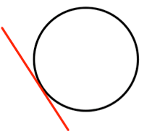  What is the name of the red line? | Factorise fully:  $$12x^{2}+18x$$ | Find the mean, median, mode and range of this set of data:  $$14, 2, 21, 21, 19, 5$$ | Share $£1050$ in the ratio $11:4$.
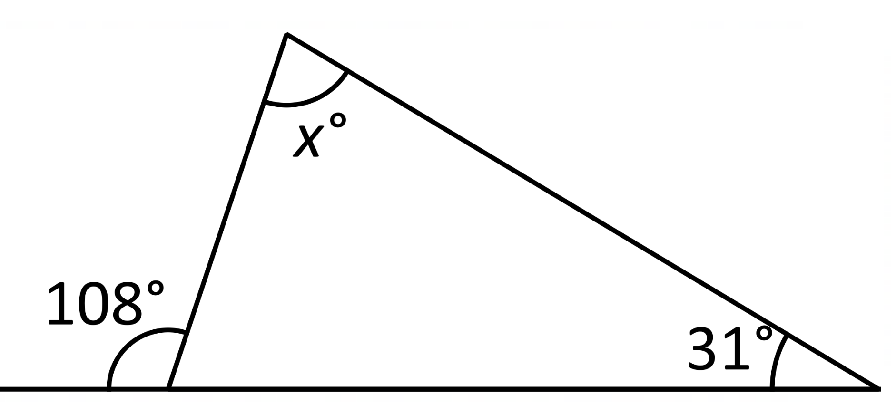  Find the size of angle $x$. | Write in ascending order:  $$\frac{2}{3},\frac{1}{2},\frac{3}{5},\frac{5}{8}$$ | Katie buys some bottles of water for £24. She sells them for £30.  Calculate her percentage profit. |  | Write $0.00465$ correct to 1 significant figure.
A model is made using a scale of $1:60$. If the actual length is $13.2m$, find the length of the model (in cm). | 100 adults were asked their favourite sport.  Each adult picked cricket, football or rugby.  45 of these adults are female.  30 of the 52 adults who like cricket are female.  35 adults like football.  9 males like rugby.  How many females like football? |  | A fair coin is flipped twice. Find the probability it lands on tails both times. | 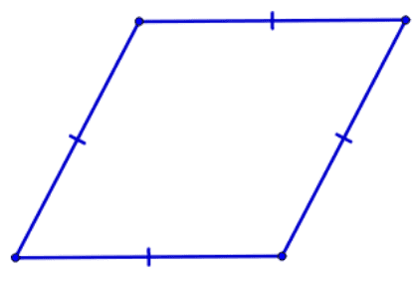What is the name of this quadrilateral?
Solve:  $$3x+y=10$$  $$2x+5y=11$$ | Convert $4cm^{2}$ into $mm^{2}$. | Simplify:  $$6a^{5}×2a^{7}$$ | Kim buys a car for $£14,000$.  Each year, it depreciates in value by 6%.  How much is the car worth after 4 years? | A rectangle measuring $4cm$ by $3cm$ is enlarged by scale factor 3. Find the area of the enlarged rectangle.
Higher Maths GCSE: Breakfast Warm Up: Target 5/6 Calculator
Expand and simplify:  $$5\left(2x-7\right)-3(2x+1)$$ | Factorise:  $$6x^{2}y+15xy^{3}$$ | Solve:  $$3x+11=5-2x$$ | Convert $7{cm}^{2}$ into ${mm}^{2}$. | Calculate:  $$\sqrt[3]{\frac{287}{47}}+{1.7}^{3}$$  Give your answer correct to 2d.p.
A car costs £23,000 when new. It depreciates at a rate of 3% per year. How much is it worth after 4 years? | Write the equation of any line parallel to  $$y=-\frac{1}{3}x+11$$ | It takes 12 workers 4 hour to dig a hole.  How long would it take 8 workers? | Simplify:  $$6x^{5}×3x^{8}$$ | Factorise:  $$x^{2}-2x-15$$
There are 60 pupils in a group. They study French or Spanish.  8 pupils study Spanish and French.  31 pupils study Spanish.  14 pupils study French.  Find the probability of selecting a student who studies neither language. |  | Simplify:  $${\left(2t^{3}\right)}^{4}$$ | Find the midpoint of $(-5, 8)$ and $(7, -2)$ | Given the exchange rate:  $$£1=\$1.68$$  - Change £270 into $.  - Change $873.60 into £.
 |  | 11 pupils have recorded their marks in a quiz.  Find the interquartile range.  $$3 7 3 7 3 3 6 5 17 13 18$$ |  | If $f\left(x\right)=x^{2}+3$and $g\left(x\right)=4x-1$,  - Find $f(2)$  - Find $gf(3)$  - Find $g^{-1}(x)$
Higher Maths GCSE: Breakfast Warm Up: Target 7+ Calculator
Solve:  $$\frac{15-x}{5}=3x+11$$ | Sketch $y=\sin\left(x\right)$ between $0°$ and $720°.$  On the same axis, sketch:  $$y=\sin{(-x)}$$  $$y=\sin{(x-30°)}$$ |  | A scientist is estimating the number of rabbits in a field.  She catches 180 rabbits, marks them and releases them.  She then catches 504 rabbits, of which 45 are marked.  Estimate the total number of rabbits in the field.
Find the equation of the line parallel to  $2y=10x+9$ passing through $(-2, -14)$ |  |  | Mo rounds a number, $x$, to 2 decimal places. The result is 0.42. State the error interval for $x.$ | It takes 12 workers 4 hour to dig a hole.  How long would it take 8 workers?
If $f\left(x\right)=3x+10$ and $g\left(x\right)=2x^{2},$  - Find: $f^{-1}(x)$  - Solve $gf\left(x\right)=g(x)$ | A number is selected.  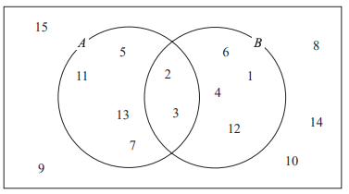  Find:  $$P(A∪B)$$  $$P(A∩B)$$  $$P\left(A^{'}\right)$$  $$P(A∪B^{'})$$ |  | Find the size of angle $x$.  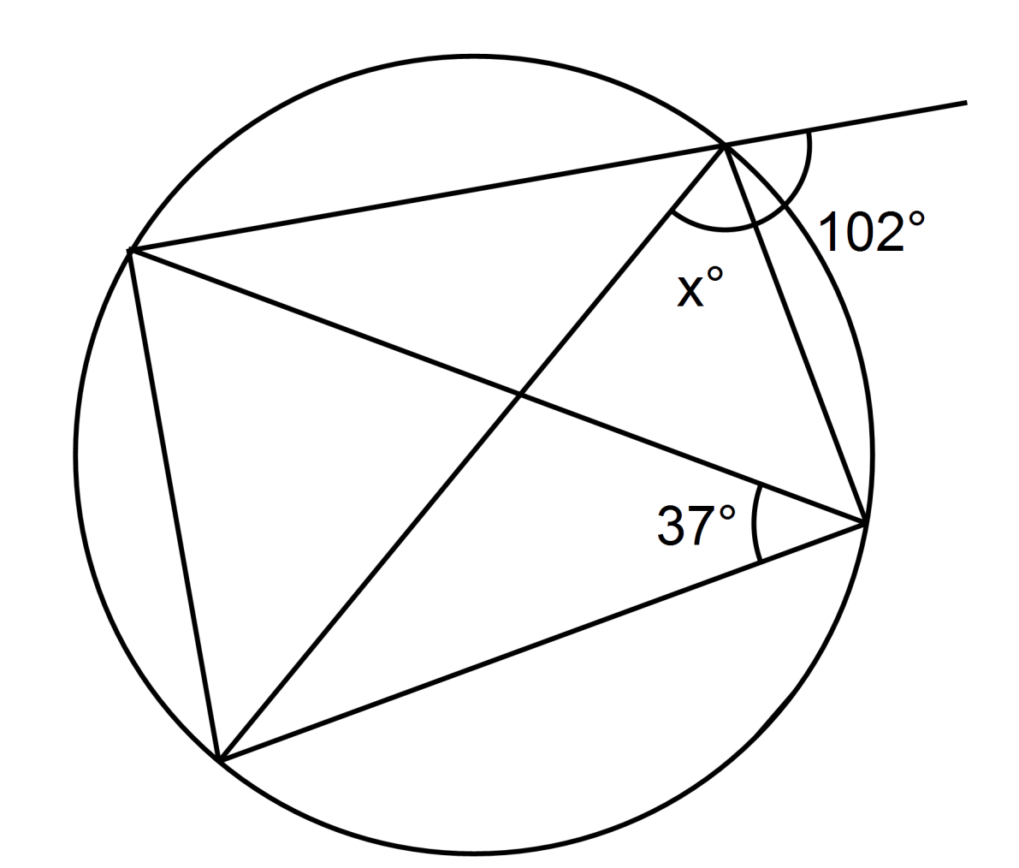 | The area of triangle ABC is $32{cm}^{2}$. AB = 8cm, BC = 12cm.  Find the size of acute angle $A\hat{B}C$ to the nearest degree.
Solve:  $$x^{2}-11x+30>0$$ | Find the largest angle of a triangle with sides length 8cm, 15cm and 20cm. | Abby and Brenda's ages are in the ratio $4:5$. In 9 years from now, their ages will be in the ratio $7:8$. How old is Abby now? | The value of a car decreases by 10% each year. How many years will it take for the value to halve? | Factorise:  $$6x^{2}+11x-10$$
Foundation Maths GCSE: Breakfast Warm Up: Target 4 Calculator
Express 0.23 as a percentage. | Find the median:  $$9, 9, 3, 12, 8$$ | onvert 7kg into grams. | Write $23.759$ to 1 decimal place. | Simplify:  $$6a+2b+a+3b$$
Find the range:  $$5, 4, 7, 16, 13, 8, 14$$ | Find the output: | Find the input: | Expand:  $$2(5x+1)$$ | Find the size of angle $x.$
Write down the first 5 multiples of 23. | Jim buys 2 coffees for £2.45 each and 3 cakes for £1.79 each. How much change will he get from £20? | Find angle $x.$ | Find the missing number:  _____ $×5=-55$ | Simplify:  $$x^{6}×x^{7}$$
Katie buys some bottles of water for £24. She sells them for £30.  Calculate her percentage profit. | Factorise:  $$10y-15$$ | Ali and Bec share some money in the ratio 3:7.  Ali gets £150. How much does Bec get? | Given that $£1=\$1.25$, convert $£60$ into $\$$. | 12 books cost $£39.$  Find the cost of 17 books.
Foundation Maths GCSE: Breakfast Warm Up: Target 5 Calculator
Expand and simplify:  $$3\left(2x+5\right)+2(x+6)$$ | What is the name of the red line? | Factorise fully:  $$12x^{2}+18x$$ | Find the mean, median, mode and range of this set of data:  $$14, 2, 21, 21, 19, 5$$ | Share $£1050$ in the ratio $11:4$.
Find the size of angle $x$. | Write in ascending order:  $$\frac{2}{3},\frac{1}{2},\frac{3}{5},\frac{5}{8}$$ | Katie buys some bottles of water for £24. She sells them for £30.  Calculate her percentage profit. |  | Write $0.00465$ correct to 1 significant figure.
A model is made using a scale of $1:60$. If the actual length is $13.2m$, find the length of the model (in cm). | 100 adults were asked their favourite sport.  Each adult picked cricket, football or rugby.  45 of these adults are female.  30 of the 52 adults who like cricket are female.  35 adults like football.  9 males like rugby.  How many females like football? |  | A fair coin is flipped twice. Find the probability it lands on tails both times. | What is the name of this quadrilateral?
Solve:  $$3x+y=10$$  $$2x+5y=11$$ | Convert $4cm^{2}$ into $mm^{2}$. | Simplify:  $$6a^{5}×2a^{7}$$ | Kim buys a car for $£14,000$.  Each year, it depreciates in value by 6%.  How much is the car worth after 4 years? | A rectangle measuring $4cm$ by $3cm$ is enlarged by scale factor 3. Find the area of the enlarged rectangle.
Higher Maths GCSE: Breakfast Warm Up: Target 5/6 Calculator
Expand and simplify:  $$5\left(2x-7\right)-3(2x+1)$$ | Factorise:  $$6x^{2}y+15xy^{3}$$ | Solve:  $$3x+11=5-2x$$ | Convert $7{cm}^{2}$ into ${mm}^{2}$. | Calculate:  $$\sqrt[3]{\frac{287}{47}}+{1.7}^{3}$$  Give your answer correct to 2d.p.
A car costs £23,000 when new. It depreciates at a rate of 3% per year. How much is it worth after 4 years? | Write the equation of any line parallel to  $$y=-\frac{1}{3}x+11$$ | It takes 12 workers 4 hour to dig a hole.  How long would it take 8 workers? | Simplify:  $$6x^{5}×3x^{8}$$ | Factorise:  $$x^{2}-2x-15$$
There are 60 pupils in a group. They study French or Spanish.  8 pupils study Spanish and French.  31 pupils study Spanish.  14 pupils study French.  Find the probability of selecting a student who studies neither language. |  | Simplify:  $${\left(2t^{3}\right)}^{4}$$ | Find the midpoint of $(-5, 8)$ and $(7, -2)$ | Given the exchange rate:  $$£1=\$1.68$$  - Change £270 into $.  - Change $873.60 into £.
 |  | 11 pupils have recorded their marks in a quiz.  Find the interquartile range.  $$3 7 3 7 3 3 6 5 17 13 18$$ |  | If $f\left(x\right)=x^{2}+3$and $g\left(x\right)=4x-1$,  - Find $f(2)$  - Find $gf(3)$  - Find $g^{-1}(x)$
Higher Maths GCSE: Breakfast Warm Up: Target 7+ Calculator
Solve:  $$\frac{15-x}{5}=3x+11$$ | Sketch $y=\sin\left(x\right)$ between $0°$ and $720°.$  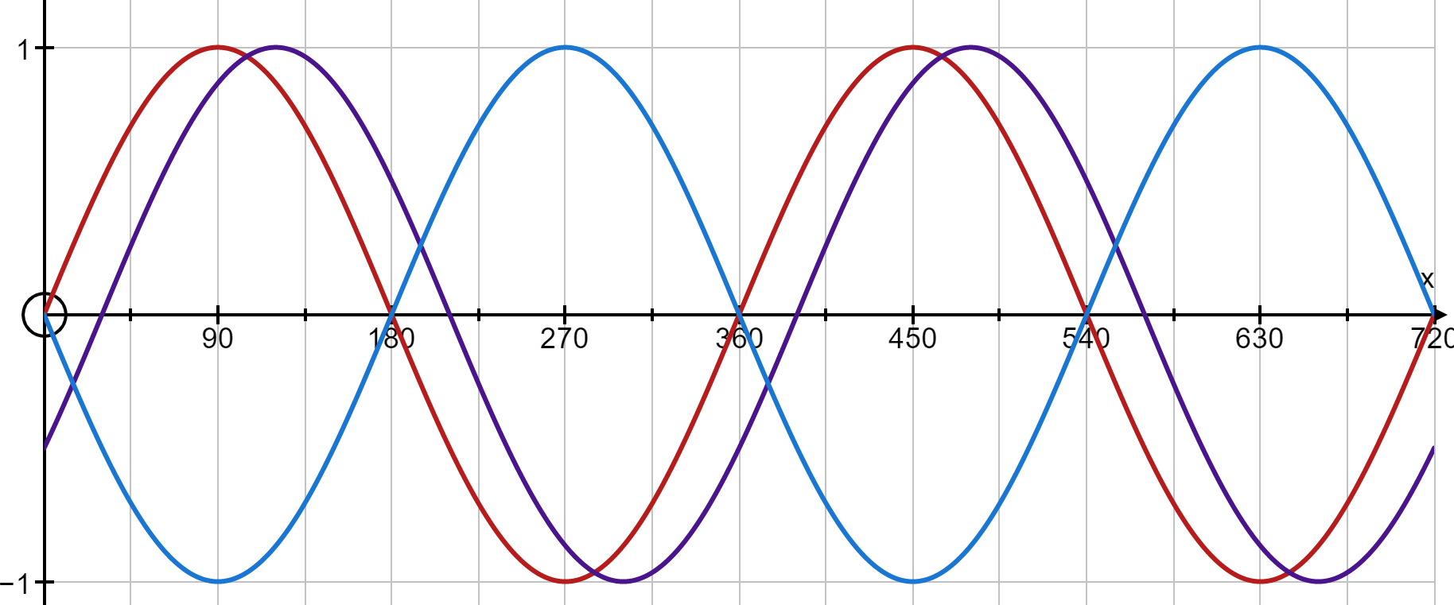  On the same axis, sketch:  $$y=\sin\left(-x\right)$$  $$y=\sin{(x-30°)}$$ |  | A scientist is estimating the number of rabbits in a field.  She catches 180 rabbits, marks them and releases them.  She then catches 504 rabbits, of which 45 are marked.  Estimate the total number of rabbits in the field.
Find the equation of the line parallel to  $2y=10x+9$ passing through $(-2, -14)$ |  |  | Mo rounds a number, $x$, to 2 decimal places. The result is 0.42. State the error interval for $x.$ | It takes 12 workers 4 hour to dig a hole.  How long would it take 8 workers?
If $f\left(x\right)=3x+10$ and $g\left(x\right)=2x^{2},$  - Find: $f^{-1}(x)$  - Solve $gf\left(x\right)=g(x)$ | A number is selected.  Find:  $$P(A∪B)$$  $$P(A∩B)$$  $$P\left(A^{'}\right)$$  $$P(A∪B^{'})$$ |  | Find the size of angle $x$. | The area of triangle ABC is $32{cm}^{2}$. AB = 8cm, BC = 12cm.  Find the size of acute angle $A\hat{B}C$ to the nearest degree.
Solve:  $$x^{2}-11x+30>0$$ | Find the largest angle of a triangle with sides length 8cm, 15cm and 20cm. | Abby and Brenda's ages are in the ratio $4:5$. In 9 years from now, their ages will be in the ratio $7:8$. How old is Abby now? | The value of a car decreases by 10% each year. How many years will it take for the value to halve? | Factorise:  $$6x^{2}+11x-10$$

